District Governors Visits July 2015
Dear Fellow Rotarians
What an amazing first month this has been visiting Rotary Clubs in our District. The biggest thing Jan and I have learned is how very special District 5060 is and how much all of you, as Rotarians, give to your individual communities. To those of you we have visited thus far, thank you again. Your warm welcome and hospitality expressed to us have been special and will stay with us a lifetime. What memories!
Yes, the visits are a lot of work, yes, the visits are tiring. However, the visits are energizing, as we meet so many talented and dedicated Rotarians.
We learned about two very special boardrooms. One old one and one new one. We stayed at the Red Lion motel in Wenatchee and they have an Ed Cadman boardroom. As you know, Doctor Ed is the only Rotary International President from our district. With 34,000 Rotary clubs in the world and only 106 presidents in our history, having a president in our district is a rarity. His home club is the downtown Wenatchee club. His theme was "You are the Key", hence the framed collages of the keys in the picture of the very handsome Ed Cadman Boardroom.
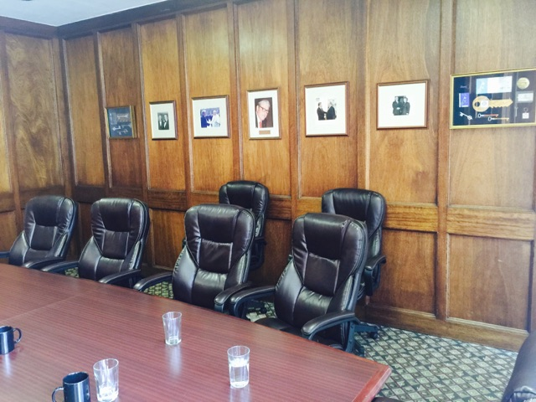 | Ed Cadman Boardroom  at the Red Lion Hotel  Wenatchee, WA
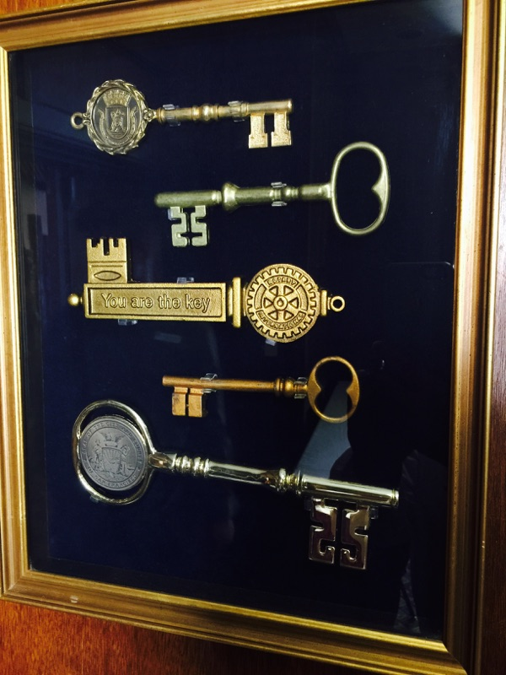 | Dr. Ed's theme for his year as  Rotary International President was:  YOU ARE THE KEY!  There were 4 shadow boxes in the boardroom and my guess is that Dr. Ed had dozens of shadow boxes in a closet somewhere as he received key gifts around the world.
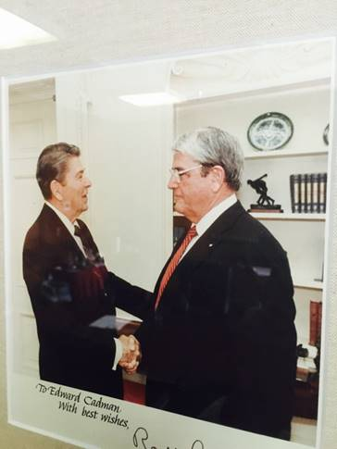 | One President to another...  U.S. President Ronald Regan meets  R.I. President Ed Cadman

The other Board room we visited was located in a brand new Chamber of Commerce facility in Lake Chelan. The Rotary Club decorated and furnished a room for the chamber and the whole community to use. I thought this was a very effective and long lasting investment in Public Relations. Jan and I are with Lake Chelan Rotary Club President Jordana and past President Les. | 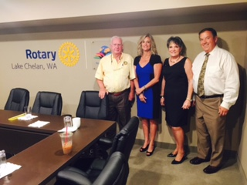

In the "It's a Small World" department, at the Wenatchee Sunrise Club President Wayne was a fellow Navy Veteran. At the Wenatchee club president Bill was a fellow Ohio State graduate. Bill, Jan and I couldn't pass up the opportunity to do the Ohio State Cheer OH--IO, OH--IO from the podium! A special gift to Jan and I included some genuine Buckeye nuts from Ohio. To keep us in check and humble when we visited the Leavenworth Club, two University of Michigan fans (our big rival) wore their Michigan hats to the cheers of Go Blue and the Michigan fight song.
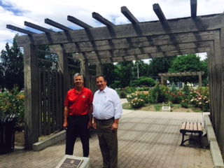 | Kamloops Rotary Rose Garden  Here is a shot of Area 1 Assistant Governor and me at the entrance of a Rose Garden in the downtown River Front Park. This was a Kamloops Rotary project dating back to 1982 in the most prominent place in the park
I wanted to highlight the importance of getting good signage that lasts. If you note this plaque was placed in 1982. Many people including Rotarians tend to forget the origination of civic projects. Go for those naming rights for your projects |  |  | 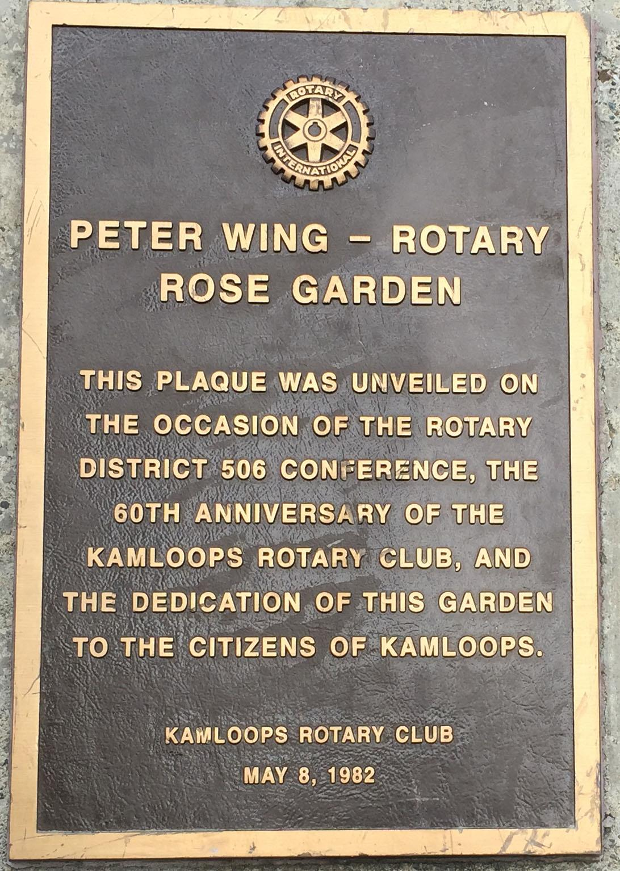

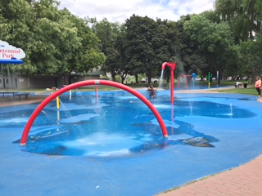 | A fun splash pool at the same Kamloops River Front Park. Is been so hot, I wanted to stop and play in the water. Not shown is huge concert bowl or band stand in this same park. Great naming rights on the bandstand too!
Back in Wenatchee. What a standout project! All the Wenatchee clubs pooled their resources including raising money from many Rotary Clubs in our district including club in Canada. They also have a splash pool, playground equipment for the kids and a Frisbee golf course, th latest thing in active play for kids and adults. That funny looking thing with the chains and a yellow top is where you have to place your "golf" shot. That is Area Six Assistant Governor Rob with me at the sign.

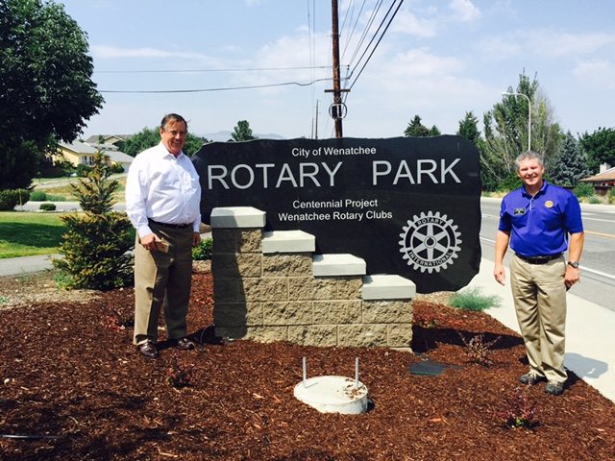 | 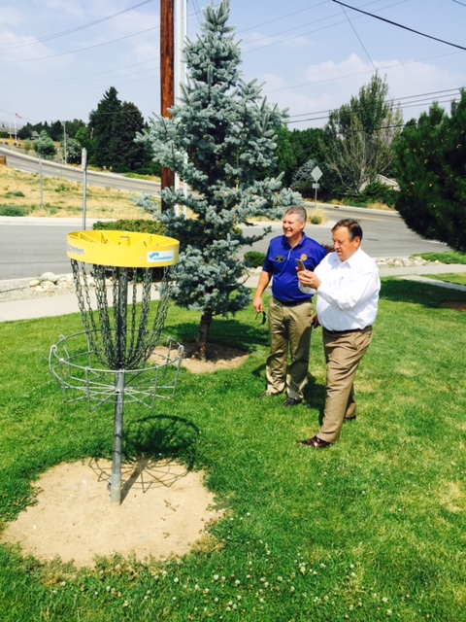

We have visited 17 Clubs from Prosser to Clearwater. Only 42 more to go, but if the next three months go by as quickly as the first month, it will be over way to soon!

Warm Regards

Greg

